
International Programmes, Partnerships & Engagements Update from Cater and Merger Consult
We remain committed to promoting good governance, leadership development, institutional strengthening, trade and investment, citizen engagement, and sustainable development through strategic partnerships, international dialogue, and capacity-building initiatives across Africa, the United Kingdom, and the global diaspora.
Upcoming International Events & Engagements
As part of our ongoing commitment to fostering dialogue, strengthening democratic institutions, promoting trade and investment, and supporting sustainable development, Cater and Merger Consult is proud to facilitate and support the following international events in the United Kingdom:

From 20-24 July, we will host an International Workshop in London and Birmingham, United Kingdom, themed:
"Strengthening Subnational Institutions and Communities Through Inclusive Governance, Public Engagement Partnerships, and Innovative Sustainable Development (SDG) Perspectives."
The workshop will explore global trends and innovations in public sector management, community development, community policing, and local government autonomy.
This event is being organised in partnership with CTP International, bringing together experts, practitioners, policymakers, and development stakeholders to share knowledge, exchange best practices, and promote collaborative approaches to sustainable governance and community development.

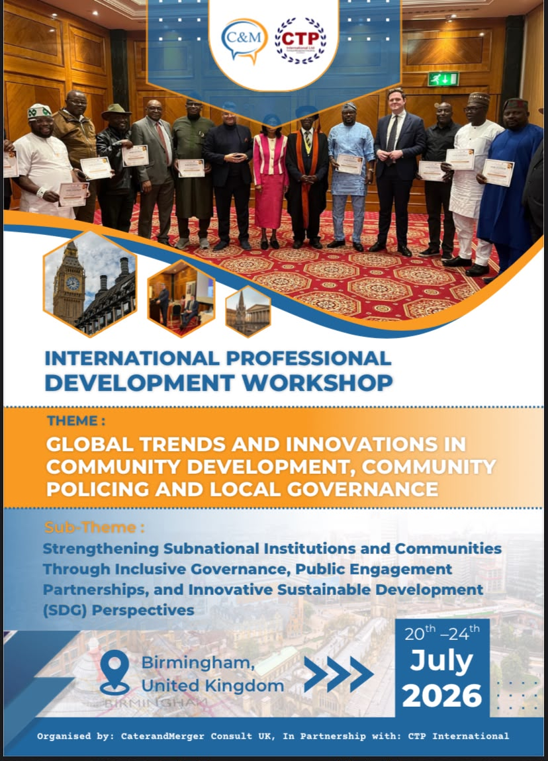

Nigeria House at the Africa Pavilion – Glasgow Commonwealth 2026
Join us at The Trades Hall, Glasgow, from 23 July to 2 August 2026 as Nigeria showcases its rich culture, trade, investment, tourism, innovation, music, food, and entertainment on the global stage. A unique platform for building partnerships, promoting business, and celebrating the best of Nigeria and Africa.
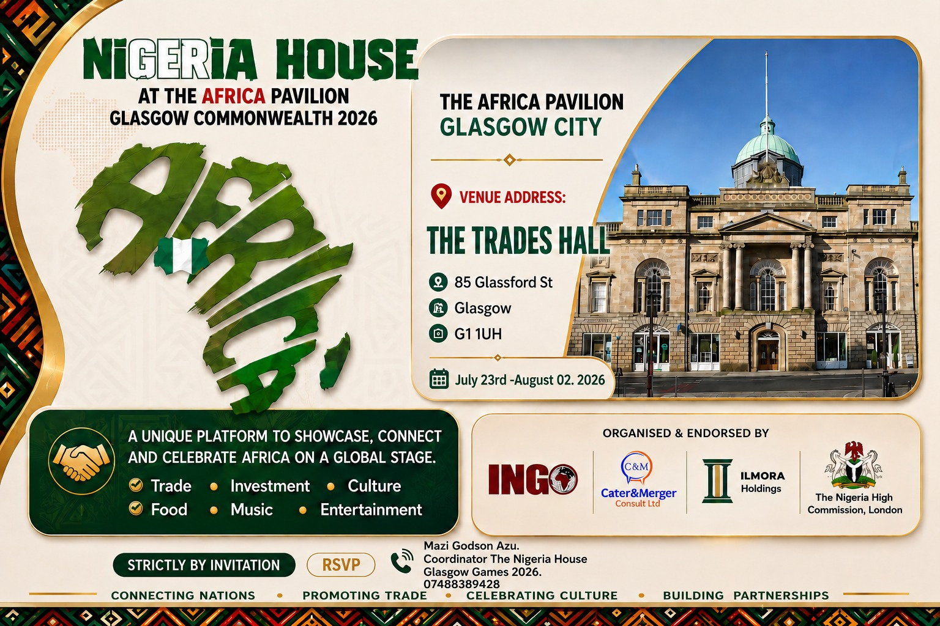

from 16-22 August 2026, we will facilitate a Legislative Leadership Training Programme and Study Tour in London, United Kingdom, for members of the Plateau State House of Assembly, themed:
"Building and Sustaining Effective Legislative Management Through Diversity and Inclusivity, with a Focus on Artificial Intelligence (AI) for Administration, Accountability, and Legislative Proceedings for Democratic Governance and Productivity."
These programmes reflect our dedication to empowering leaders, strengthening institutions, promoting transparency, encouraging citizen engagement, and advancing innovative approaches to governance and development.
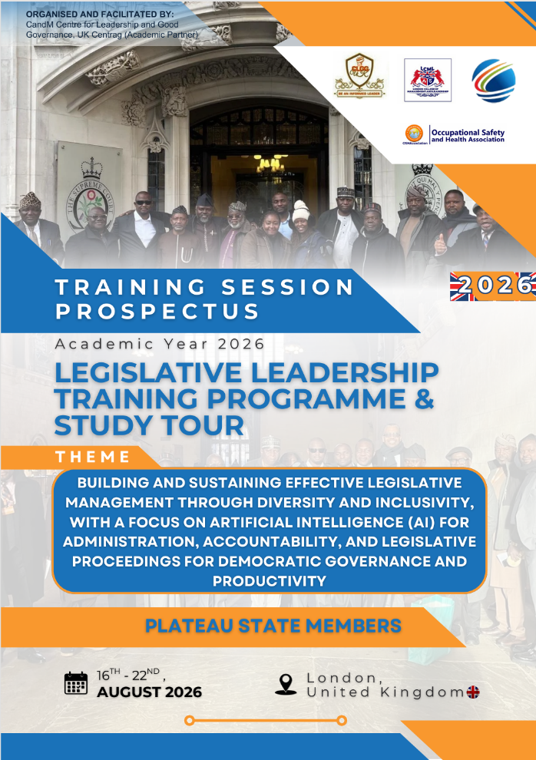

The Voice Achievers Award London 2026
Date: 21 August 2026
Venue: Hilton London Kensington Hotel, London, United Kingdom
We are proud to partner with The Voice News Magazine for the 15th Edition of The Voice Achievers Award 2026 under the theme:
"Putting Africa in the Right Perspective – Focusing on Mental Empowerment for Economic Inclusion and Growth."
The programme will bring together business leaders, policymakers, educators, entrepreneurs, and development professionals to celebrate excellence, inspire innovation, and encourage sustainable socioeconomic growth across Africa and the diaspora.
The event will feature a Business Dialogue Session and a Gala Awards Night recognizing outstanding contributions to leadership, education, business, and community development.
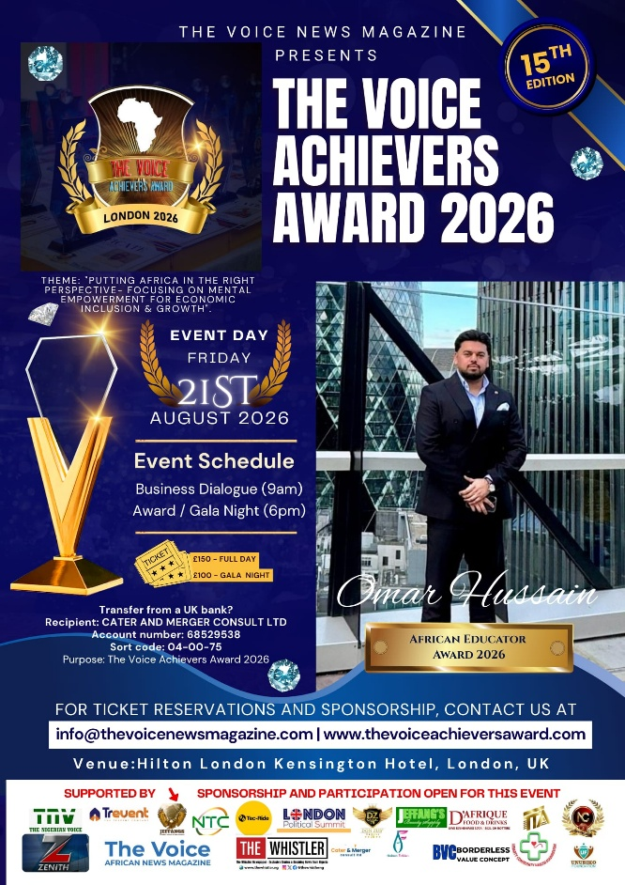

Governor of Benue State Visit to the United Kingdom
Date: To Be Announced
Cater and Merger Consult is facilitating a strategic visit to the United Kingdom by the Executive Governor of Benue State, Nigeria, Rev. Fr. Dr. Hyacinth Iormem Alia.
The visit will include engagements at the Institute of Directors (IoD), House of Parliament, and the University of Cambridge, United Kingdom, in relation to a special book donation initiative in Benue State.
The programme is designed to strengthen educational partnerships, encourage knowledge exchange, promote international collaboration, and explore opportunities that support learning, leadership development, and sustainable community impact through education.

United Kingdom & Europe Legislative Leadership and Good Governance Training & Study Tour 2026
Date: 23–31 August 2026
Locations: London (United Kingdom), Brussels & Liège (Belgium), Aachen (Germany), and Maastricht (Netherlands)
Cater and Merger Consult UK, in collaboration with SeaNexus International Germany and academic and institutional partners, is pleased to facilitate the United Kingdom & Europe Legislative Leadership and Good Governance Training & Study Tour 2026, themed:
"The Legislature and the Constituency: Understanding Democratic Representation, Legislative Responsibilities, the Power of Artificial Intelligence for Accountability, Parliamentary Proceedings and Effective Governance for Subnational Development."
Sub-Theme:
"Bridging Subnational Legislatures and Local Government: Cross-Border Governance, SDG Integration, Sustainable Cities and Citizen Engagement — European Continental Perspectives."
The programme is a high-level international capacity-building initiative designed for legislators, policymakers, local government leaders, senior public officials, and governance practitioners. It combines academic training, institutional exposure, parliamentary engagement, and cross-border European governance study visits to strengthen democratic leadership, legislative effectiveness, accountability, and sustainable development.
Participants will gain practical insights into democratic governance, constituency engagement, legislative oversight, parliamentary procedures, ethics and transparency, Artificial Intelligence for governance and accountability, evidence-based policymaking, and cross-border governance collaboration.
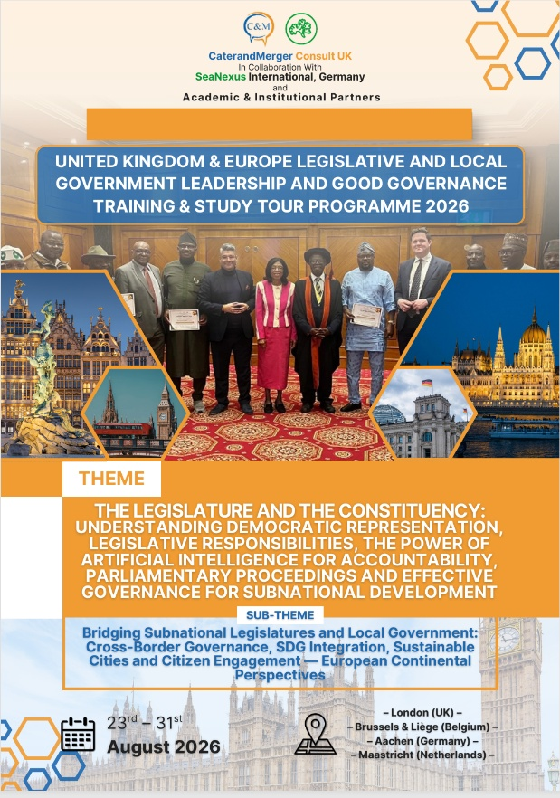

LPSA 2026 Events

11th Annual London Political Summit & Awards 2026
Date: 13–14 October 2026
Venue: Institute of Directors (IoD), Pall Mall, London and House of Lords, Westminster Parliament, London, United Kingdom
Theme:
"Pan-Africanism and the African Union: The People, Place, Politics, Power and Peace – Trade by Peace and the Raila Odinga Diplomacy Approach"
Cater and Merger Consult is proud to support and participate in the 11th Annual London Political Summit & Awards (LPSA) 2026, a prestigious international platform that brings together political leaders, diplomats, parliamentarians, business executives, development partners, academics, and civil society stakeholders to discuss governance, diplomacy, trade, investment, and sustainable development.
The summit will provide a platform for high-level policy dialogue, leadership engagement, international networking, and strategic partnerships aimed at strengthening cooperation between Africa, the United Kingdom, and the global community.
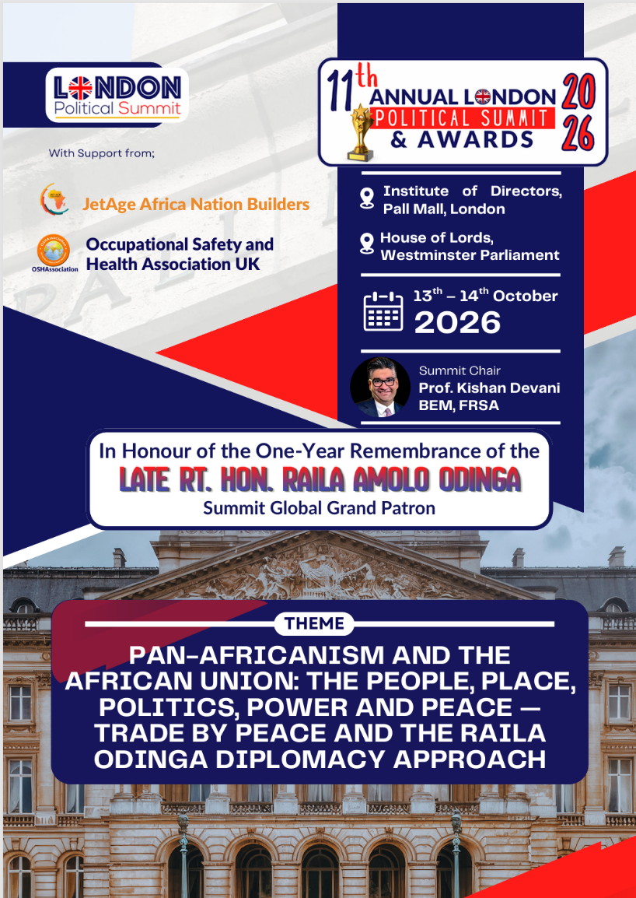

London Political Summit & Awards (LPSA) 2026 – Somaliland Edition
Date: 19-22 October 2026
Venue: Hargeisa, Republic of Somaliland
Theme:
"Pan-Africanism and the African Union: The People, Place, Politics, Power and Peace"
Sub-Theme:
"The Role of Youths in Africa Development"
Following the London summit, Cater and Merger Consult will facilitate and support the first African edition of the London Political Summit & Awards (LPSA) 2026 in partnership with the Government of Somaliland.
The summit will bring together government officials, policymakers, traditional leaders, development partners, youth representatives, investors, entrepreneurs, academics, and members of the African diaspora to explore practical solutions to governance, leadership, peacebuilding, economic development, and youth empowerment across the continent.
The Somaliland edition represents a significant milestone in expanding the London Political Summit & Awards platform into Africa while creating opportunities for dialogue, partnership-building, investment promotion, youth engagement, and sustainable development across the continent.
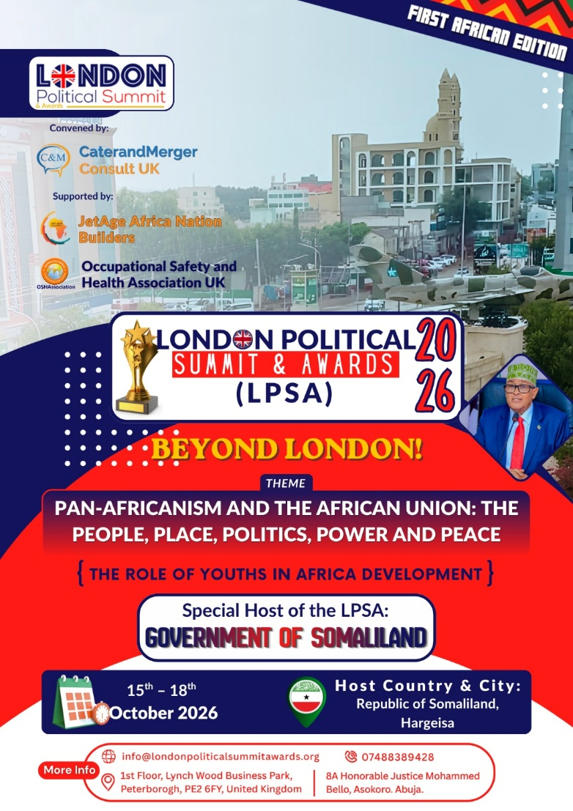

Our Recent International Engagements & Strategic Partnerships
In line with its commitment to strengthening governance, economic diplomacy, and institutional collaboration across Africa and the diaspora, Cater and Merger Consult has actively participated in several high-level international programmes, summits, and networking engagements across the United Kingdom and beyond.
These engagements have provided valuable platforms for dialogue, partnership-building, knowledge exchange, and exposure to global best practices in leadership, trade, innovation, and sustainable development.

Government of the Republic of Somaliland Officially Endorses and Confirms Hosting of the 11th Annual London Political Summit and Awards (LPSA) 2026 – First Africa Edition, “Beyond London”
The Government of the Republic of Somaliland has officially endorsed and confirmed its hosting of the 11th Annual London Political Summit and Awards (LPSA) 2026 – First Africa Edition, "Beyond London," in Hargeisa from 15 to 18 October 2026. Organised by CaterandMerger Consult UK and its partners, the summit marks the first time the event will be held in Africa after more than a decade in London. It will bring together government leaders, diplomats, business executives, academics, and development partners to discuss governance, peace, trade, investment, and Pan-African cooperation while showcasing Somaliland's development and investment opportunities.
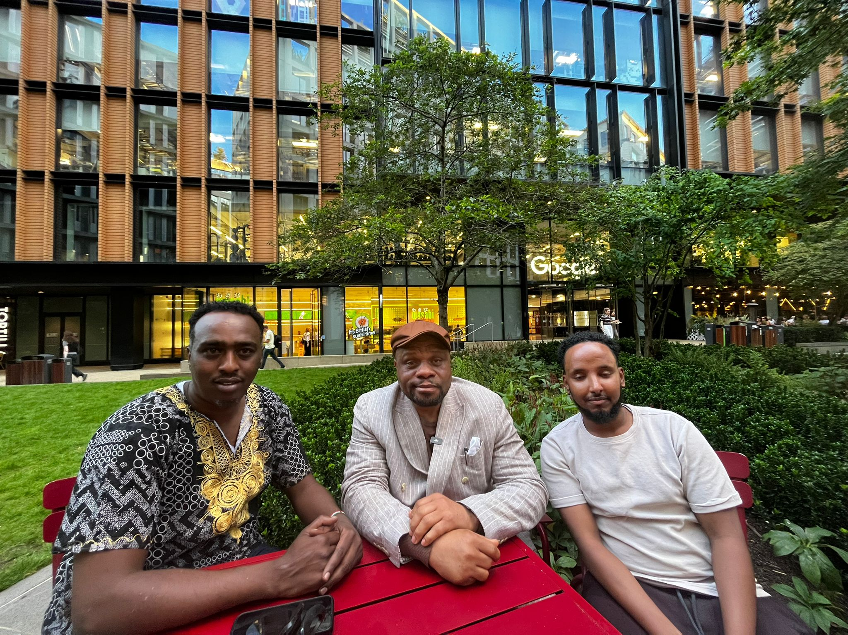
https://caterandmergerconsult.com/government-of-the-republic-of-somaliland-officially-endorses-and-confirms-hosting-of-the-11th-annual-london-political-summit-and-awards-lpsa-2026-first-africa-edition-beyond-lond/

REPORT OF STRATEGIC ENGAGEMENT BETWEEN NIGERIA HOUSE TEAM AND RED TIGER MARKETING AGENCY
The Nigeria House Team held a strategic meeting with Red Tiger Marketing Agency, represented by CEO Lawrence Miller and Commercial Lead Yash, at the Nigeria High Commission in London to explore partnership opportunities for Nigeria House at the Africa Pavilion during the Glasgow Commonwealth Games. Discussions focused on sponsorship, corporate participation, and strategic collaboration, including a proposal to engage Nottingham Forest Football Club as a major sponsor through Red Tiger's commercial network. Both parties identified strong mutual commercial benefits, expressed optimism about the partnership, and agreed to continue discussions, with Red Tiger Marketing expected to outline the next steps following the meeting.

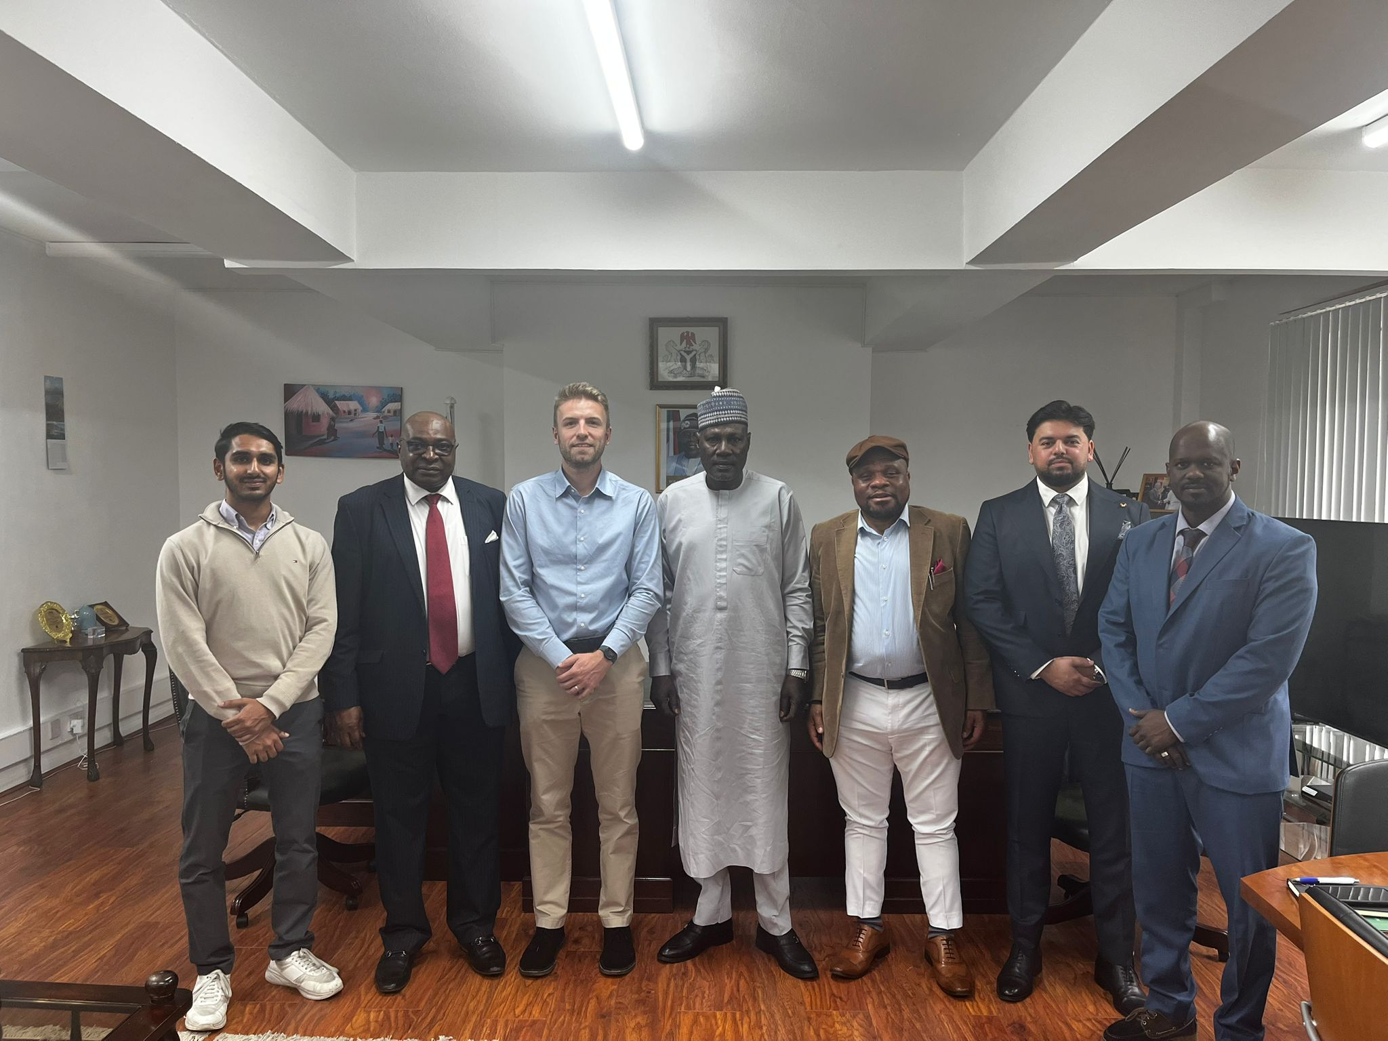

https://caterandmergerconsult.com/report-of-strategic-engagement-between-nigeria-house-team-and-red-tiger-marketing-agency/

Ethiopia Showcases Investment Potential at Africa Business and Diplomatic Networking Evening in London
The Africa Business and Diplomatic Networking Evening, hosted by the Embassy of Ethiopia in London in collaboration with the Westminster Africa Business Association (WABA), brought together diplomats, government officials, investors, and business leaders to strengthen UK-Africa trade and investment ties. The event showcased Ethiopia's economic potential, infrastructure development, and investment opportunities across key sectors, while also celebrating its rich cultural heritage through traditional performances, cuisine, and the renowned Ethiopian coffee ceremony. It reinforced Ethiopia's commitment to international partnerships and highlighted the growing importance of economic diplomacy in promoting sustainable development and regional cooperation.
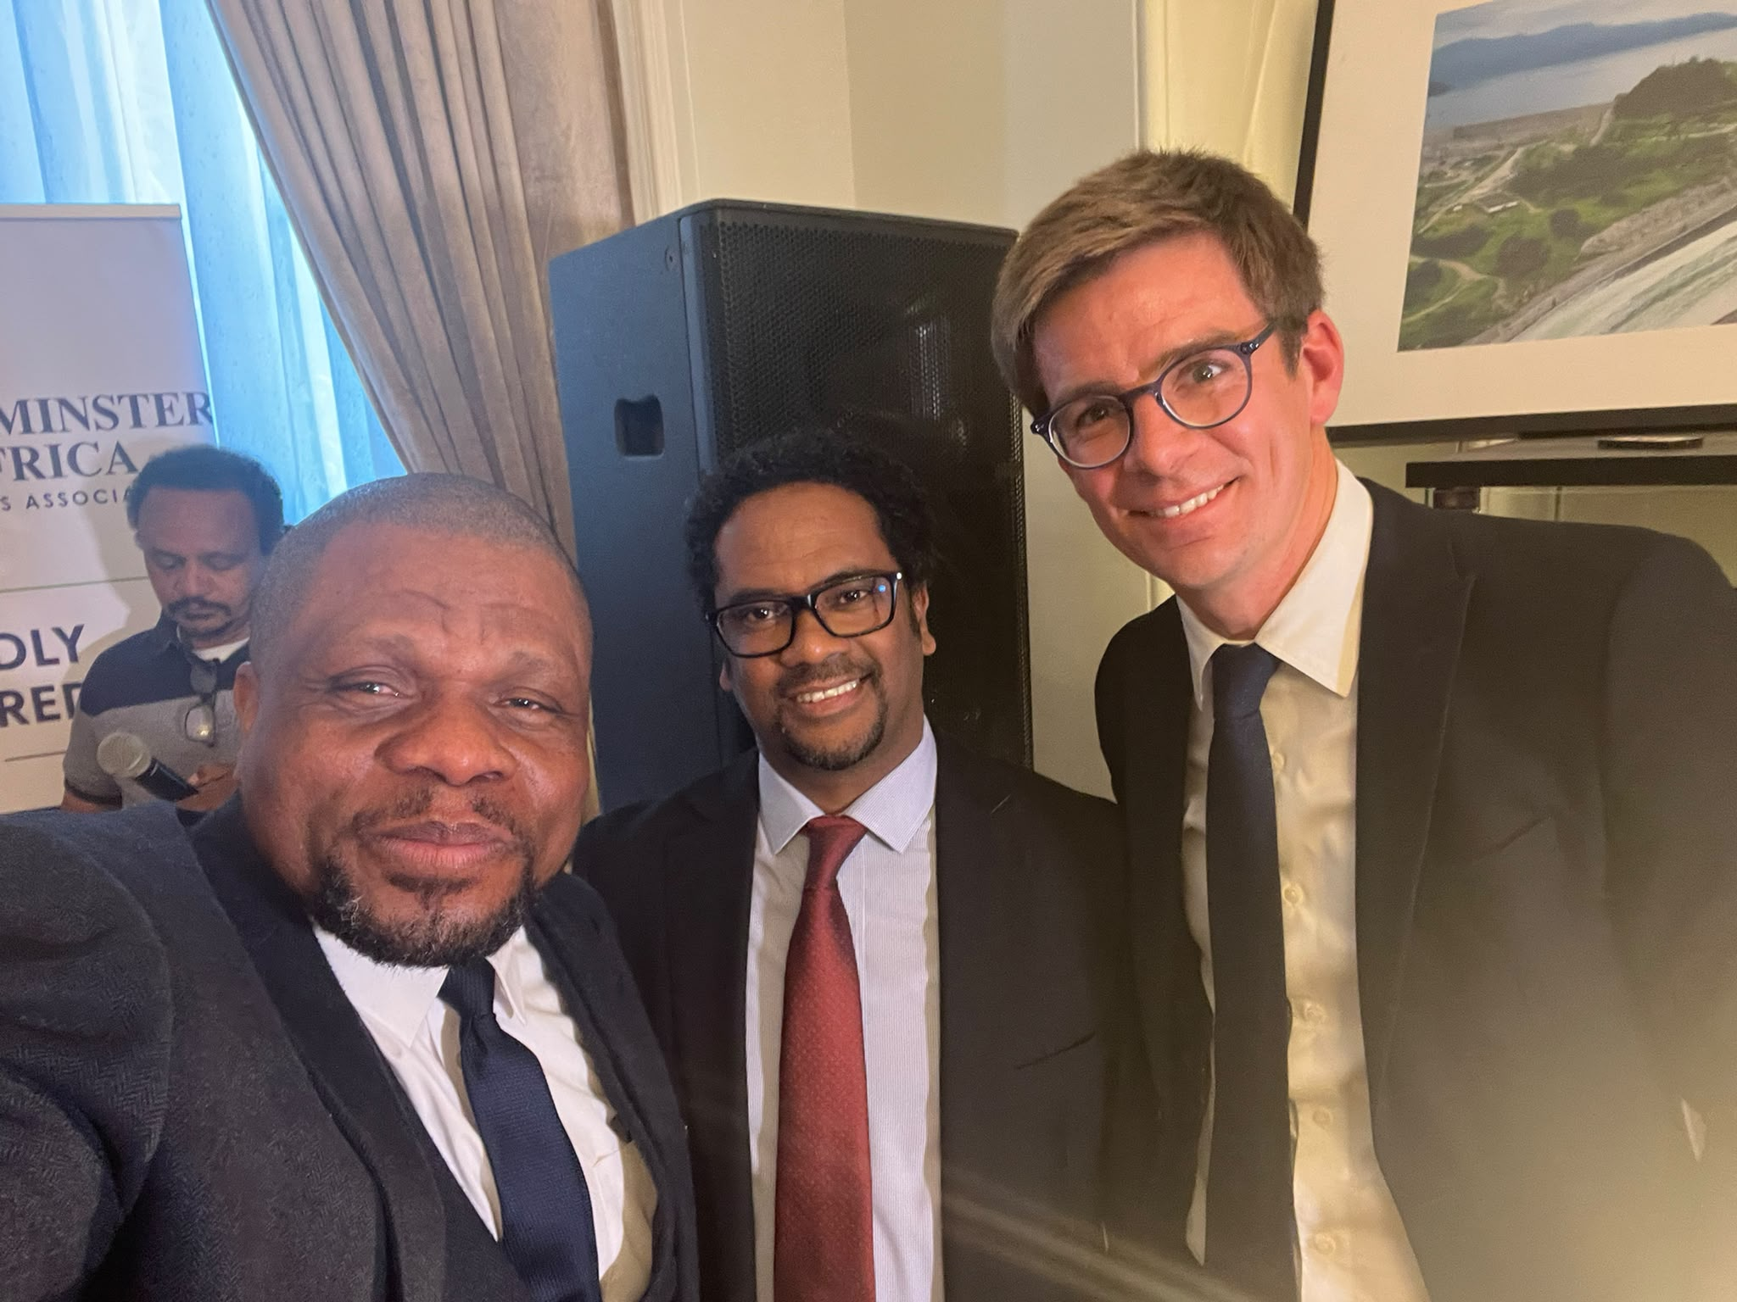
https://caterandmergerconsult.com/ethiopia-showcases-investment-potential-at-africa-business-and-diplomatic-networking-evening-in-london/

Institute of Directors (IoD) AGM 2026: Creating New Partnerships Across the Business Community
The 2026 Annual General Meeting (AGM) of the Institute of Directors (IoD), held at 116 Pall Mall, London, brought together business leaders, directors, entrepreneurs, and professionals to discuss the theme "Business: A Force for Good." The event featured discussions on ethical leadership, sustainable economic growth, corporate governance, and the role of businesses in creating positive social impact. Beyond the formal proceedings, the AGM provided valuable networking opportunities, enabling attendees to build strategic partnerships and exchange ideas. The event reinforced the importance of responsible leadership, collaboration, and professional engagement in shaping the future of business and strengthening the UK's business community.
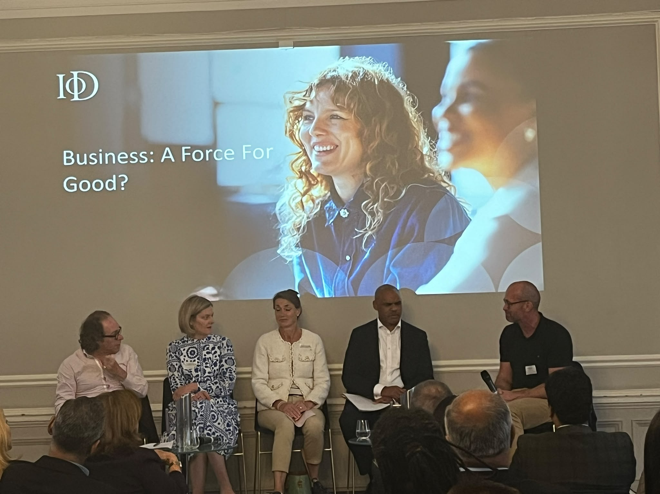

https://caterandmergerconsult.com/institute-of-directors-iod-agm-2026-creating-new-partnerships-across-the-business-community/

INGO UK Appoints CaterandMerger Consult UK as Coordinator of the Nigeria House at Africa Pavilion Glasgow 2026
CaterandMerger Consult UK has been appointed by INGO UK to coordinate the Nigeria House at Africa Pavilion Glasgow 2026, with its CEO, Mazi Godson Azu, leading the initiative. The appointment was announced by Chief Ambassador Uzo Owunne during a meeting with Nigeria's High Commissioner to the United Kingdom, Ambassador Amin Dalhatu. Nigeria House will serve as a platform to showcase Nigeria's business, culture, tourism, innovation, and investment opportunities through exhibitions, networking events, and business forums. The initiative aims to strengthen international partnerships, promote Nigeria's global image, and encourage participation from businesses, investors, cultural organisations, entrepreneurs, and the Nigerian diaspora.
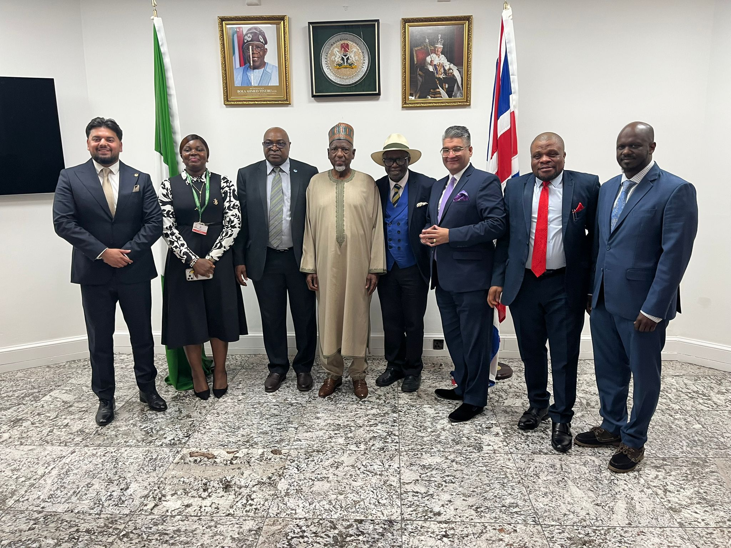
https://caterandmergerconsult.com/ingo-uk-appoints-caterandmerger-consult-uk-as-coordinator-of-the-nigeria-house-at-africa-pavilion-glasgow-2026/

CATERANDMERGER CONSULT UK COMMENDS GOVERNOR HYACINTH ALIA ON THE INAUGURATION OF THE TASK FORCE FOR THE TAKE-OFF OF BENUE STATE UNIVERSITY OF AGRICULTURE, SCIENCE AND TECHNOLOGY, IHUGH
CaterandMerger Consult UK has commended Benue State Governor Hyacinth Alia for inaugurating the Task Force Committee to oversee the establishment of the Benue State University of Agriculture, Science and Technology, Ihugh. The organisation described the initiative as a major step toward advancing education, agricultural innovation, entrepreneurship, and sustainable development in the state. It also reaffirmed its commitment to supporting the university through international partnerships and welcomed the Governor's planned visit to the United Kingdom to explore collaborations with universities, agricultural institutions, education experts, and potential investors. CaterandMerger Consult UK expressed confidence that the institution will become a centre of excellence for research, innovation, and practical learning in Nigeria and across Africa.
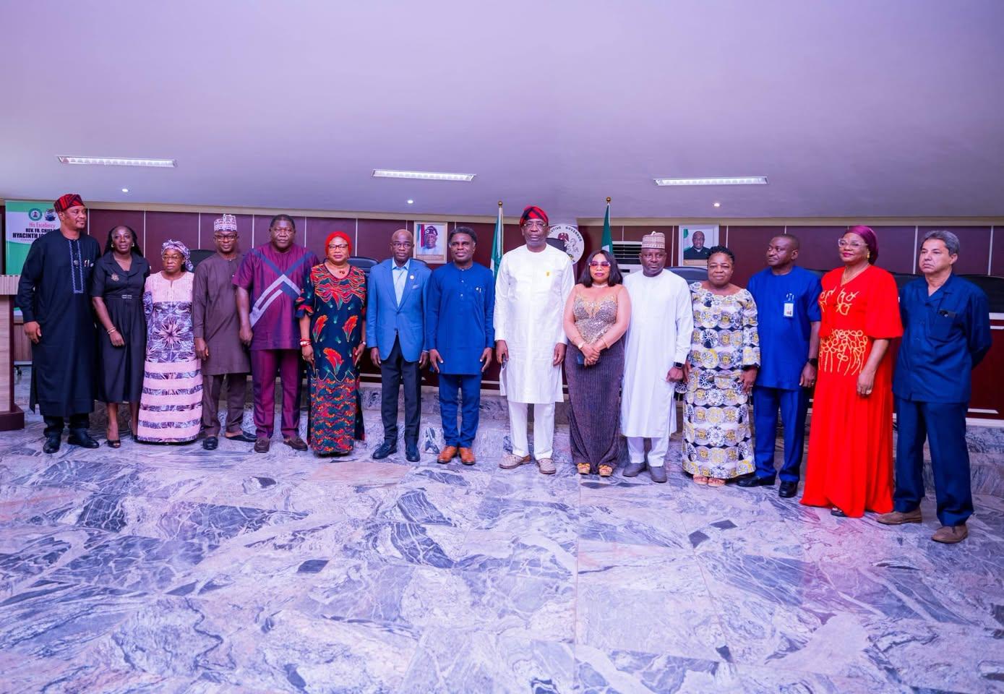
https://caterandmergerconsult.com/caterandmerger-consult-uk-commends-governor-hyacinth-alia-on-the-inauguration-of-the-task-force-for-the-take-off-of-benue-state-university-of-agriculture-science-and-technology-ihugh/
The Sierra Leone Government Engages with Its Diaspora Community and Friends of Sierra Leone at the Historic Civic Day in London
The Government of Sierra Leone engaged with its diaspora community and friends of the country during the inaugural Sierra Leone Civic Day in London, an initiative organised by the Ministry of Information and Civic Education with support from the Sierra Leone High Commission. Led by Vice President Dr. Mohamed Juldeh Jalloh, the event brought together government officials, diplomats, business leaders, and community members to discuss national development, governance, investment, and economic reforms. Through panel discussions and an interactive question-and-answer session, the government highlighted its commitment to transparency, civic engagement, and diaspora participation, while encouraging Sierra Leoneans abroad to contribute to the country's growth and development.

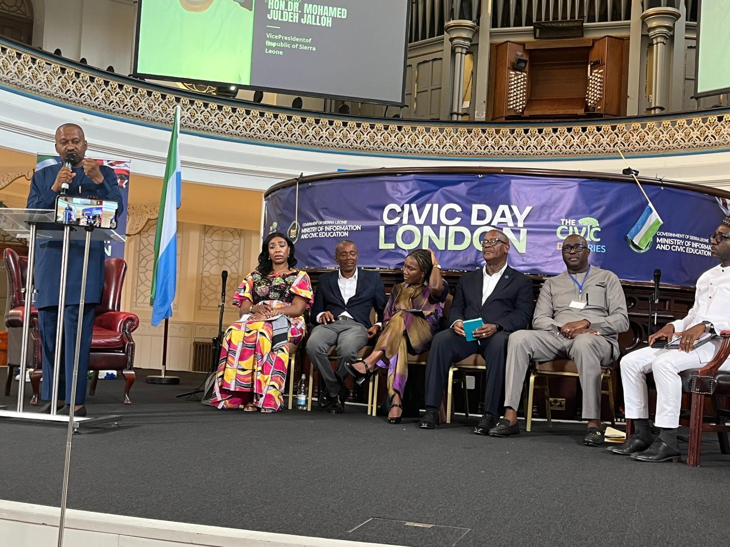
https://caterandmergerconsult.com/the-sierra-leone-government-engages-with-its-diaspora-community-and-friends-of-sierra-leone-at-the-historic-civic-day-in-london/

CHATHAM HOUSE ROUNDTABLE DIALOGUE ON NIGERIA’S 2027 ELECTIONS: DEPUTY SPEAKER BENJAMIN KALU ADVOCATES ELECTORAL REFORMS AND SECURITY MEASURES
A high-level Roundtable Dialogue at Chatham House, London, brought together diplomats, academics, policy experts, and members of the Nigerian diaspora to discuss Nigeria's 2027 General Elections and the country's democratic future. Delivering the keynote address, Deputy Speaker Benjamin Kalu outlined proposed electoral reforms under the Electoral Act 2026, including mandatory electronic transmission of results, improved voter registration, stronger political party transparency, and enhanced legal safeguards. He also advocated for the creation of state police to improve local security, supported the establishment of an Election Offences Commission, and reaffirmed the government's commitment to electoral integrity, security, and greater inclusion of women, youth, internally displaced persons, and the diaspora in Nigeria's democratic process. The dialogue highlighted ongoing efforts to strengthen public confidence in the electoral system ahead of the 2027 elections.

RECEPTION HELD IN LONDON TO HONOUR RT. HON. SIR SAM I. ONUIGBO ON HIS APPOINTMENT AS PRESIDENT OF GLOBE INTERNATIONAL

A reception in London was held to honour Rt. Hon. Sir Sam I. Onuigbo following his appointment as President of GLOBE International, a leading global parliamentary network focused on climate action and sustainable development. Hosted by Evangelist Abraham N. Osondu (Snr.), the event brought together Nigerian community leaders, professionals, and distinguished guests to celebrate Onuigbo's contributions to environmental governance and public service. During the reception, he reflected on his role in championing Nigeria's Climate Change Act, expressed gratitude to his supporters, and reaffirmed his commitment to advancing global climate leadership. The occasion also highlighted Africa's growing influence in international climate diplomacy and encouraged greater Nigerian participation in global policy and leadership.
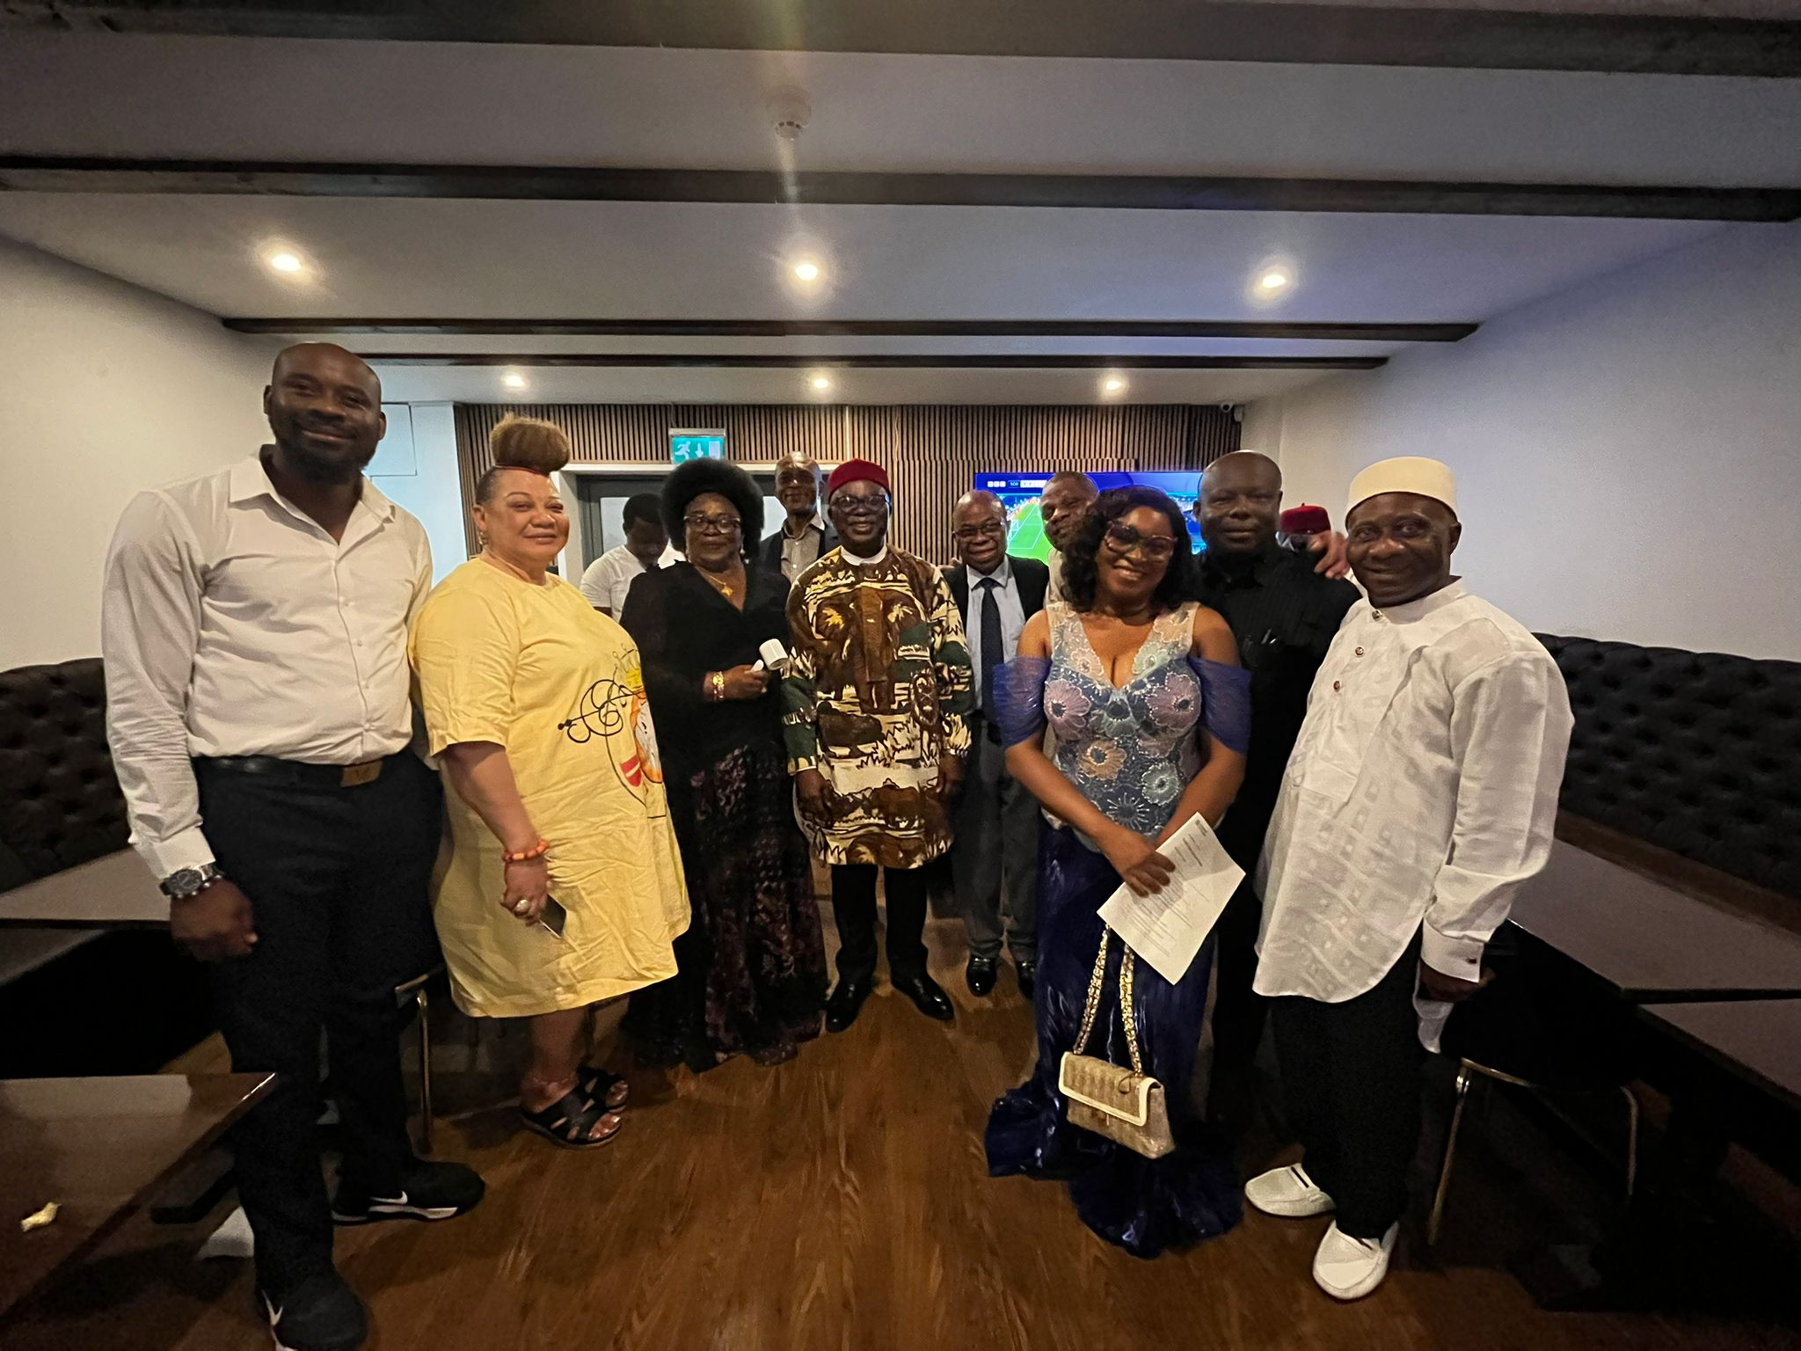
https://caterandmergerconsult.com/reception-held-in-london-to-honour-rt-hon-sir-sam-i-onuigbo-on-his-appointment-as-president-of-globe-international/

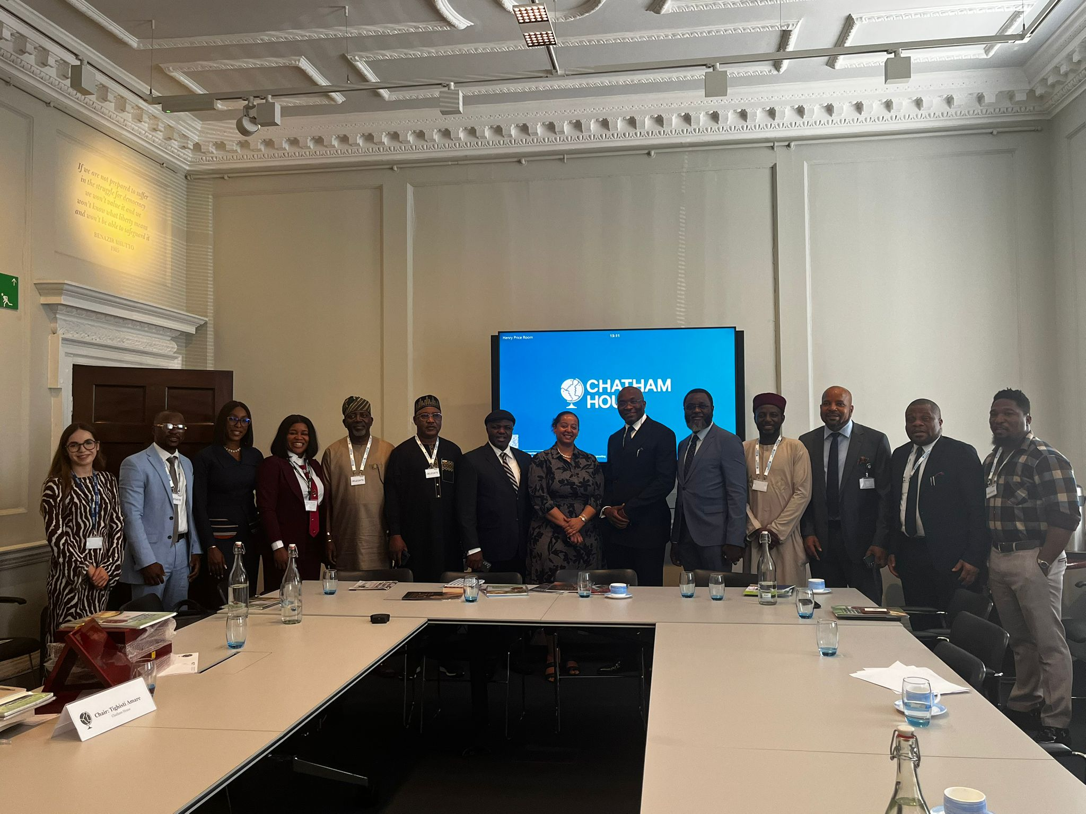
https://caterandmergerconsult.com/chatham-house-roundtable-dialogue-on-nigerias-2027-elections-deputy-speaker-benjamin-kalu-advocates-electoral-reforms-and-security-measures/

Ghana-UK Investment Summit 2026 – London
Cater and Merger Consult participated in the prestigious Ghana-UK Investment Summit held at Raffles London at The OWO, convened as part of the official visit of the President of the Republic of Ghana, H.E. John Dramani Mahama.
The summit brought together government officials, investors, development partners, and diaspora stakeholders to explore opportunities across infrastructure, agriculture, energy, tourism, manufacturing, and digital innovation. Key discussions highlighted the importance of economic diplomacy, diaspora investment, and public-private partnerships in advancing sustainable development across Africa.
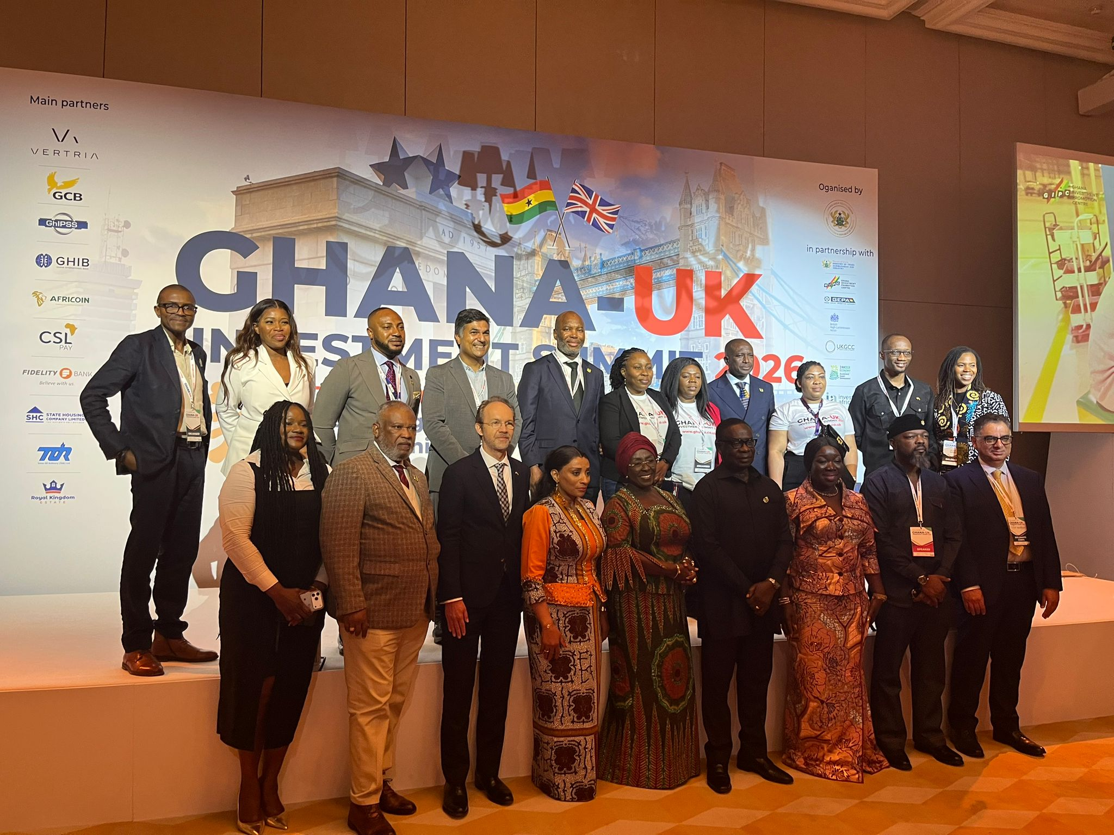
https://caterandmergerconsult.com/how-ghana-is-shaping-the-dynamics-of-diplomacy-and-diaspora-engagement-for-effective-collaboration/

Nigerian-British Chamber of Commerce (NBCC) UK Chapter Launch – London
Cater and Merger Consult attended the official launch of the NBCC UK Chapter hosted at the residence of the Nigerian High Commissioner to the Court of St James's.
The event marked a renewed effort to strengthen Nigeria–UK trade and investment relations, featuring contributions from leading government representatives, business executives, and diaspora stakeholders. The engagement reinforced the importance of structured trade diplomacy, private sector collaboration, and diaspora-driven economic development.
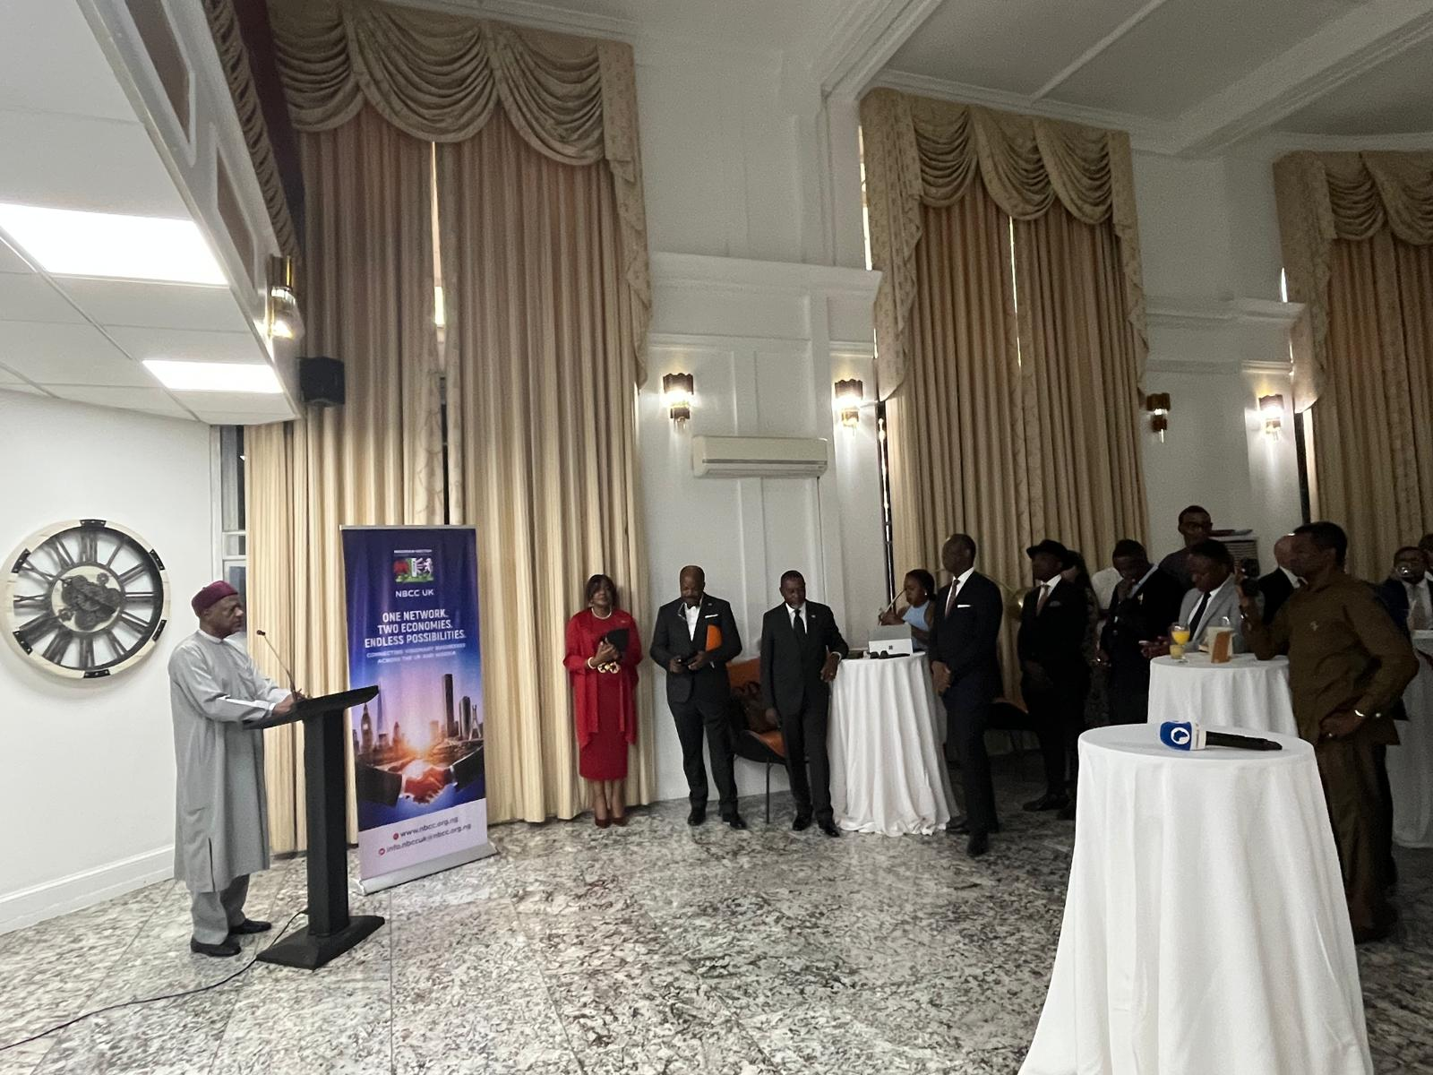

https://caterandmergerconsult.com/the-new-business-networking-platform-between-nbcc-and-uk-businesses/

AfreTrade Entrepreneur Festival Stakeholder Engagement – Lagos/London Network
Cater and Merger Consult participated in strategic dialogues ahead of the AfreTrade Entrepreneur Festival Lagos 2026, focused on advancing intra-African trade, entrepreneurship, youth empowerment, and diaspora investment.
The engagement explored AfreTrade's three-pillar model—trade and entrepreneurship, youth job creation, and skills development—emphasising Africa's readiness for a new era of innovation-led economic transformation.
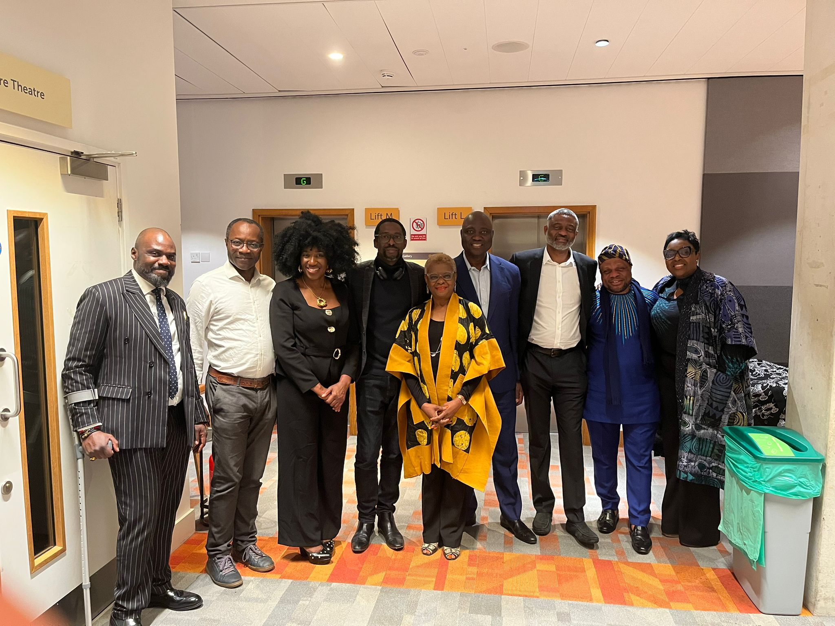
https://caterandmergerconsult.com/is-africa-and-the-african-diaspora-ready-for-the-trade-entrepreneur-festival-in-lagos/

Institute of Directors (IoD) Spring Networking Event – London
Cater and Merger Consult engaged with professionals and leaders across the education, fintech, and Africa-focused IoD groups at a high-level networking event in London.
The discussions focused on leadership development, digital transformation, cross-border collaboration, and the role of education and financial technology in driving socioeconomic progress across Africa and the United Kingdom.
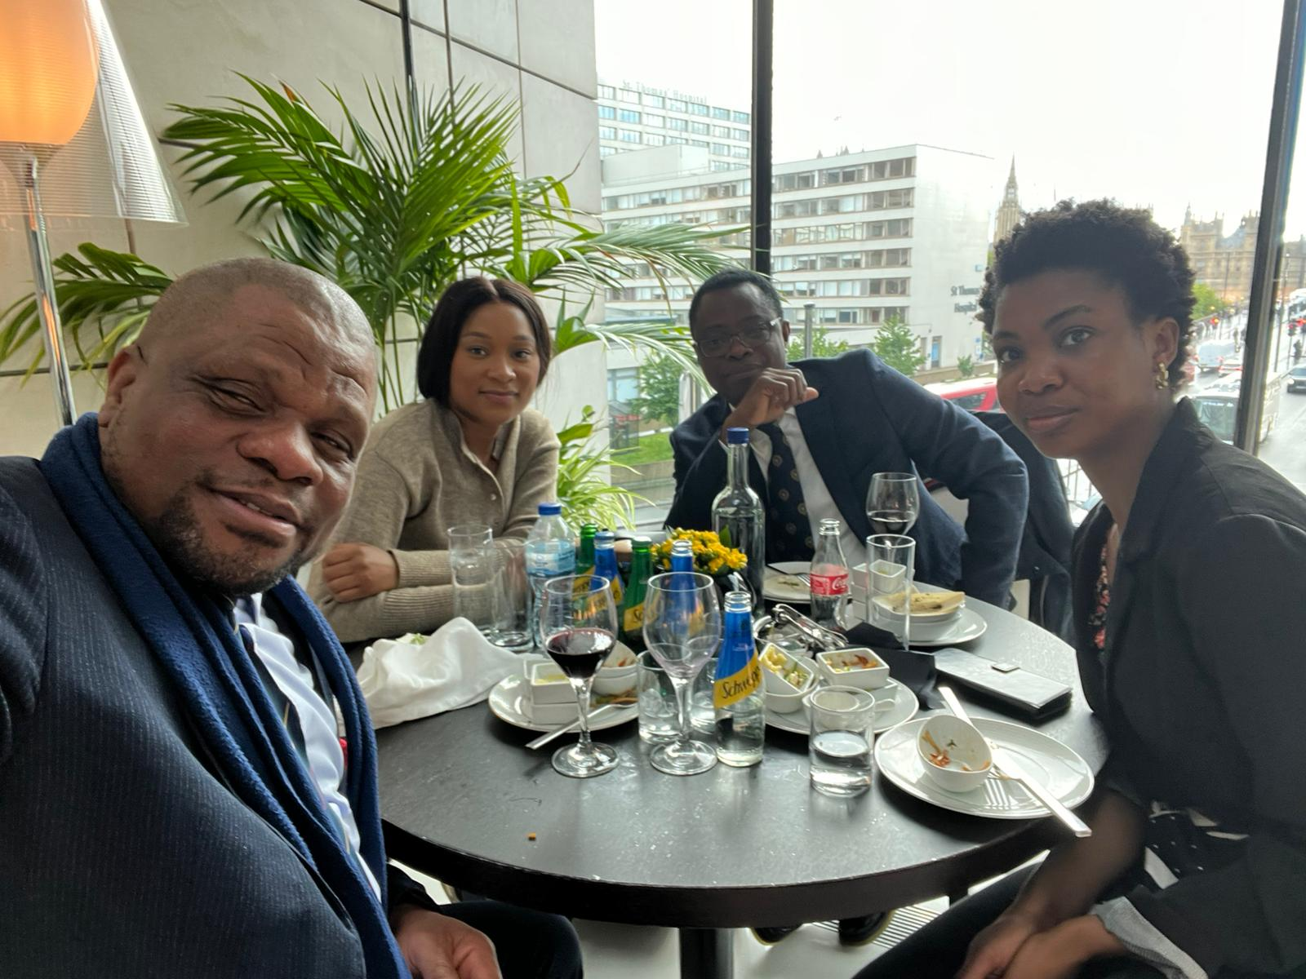
https://caterandmergerconsult.com/iod-the-power-of-collaboration-and-networking/

Africa Writes – Royal African Society, SOAS University of London
Cater and Merger Consult also attended Africa Writes, a leading literary and cultural event celebrating African storytelling, identity, and intellectual expression.
The event featured authors exploring themes of identity, history, and belonging, reinforcing the importance of African-led narratives in shaping global understanding. It provided valuable opportunities for cultural exchange, networking, and intellectual engagement.
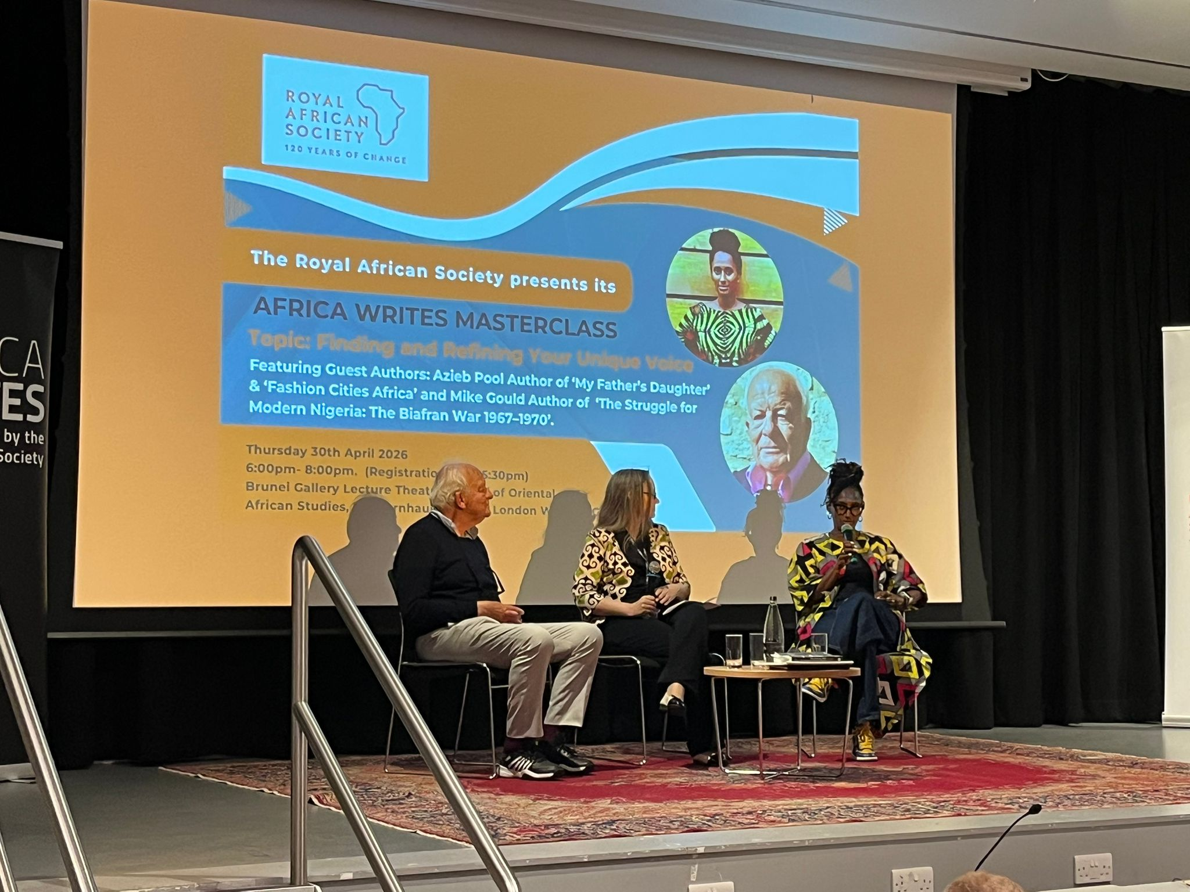
https://caterandmergerconsult.com/reflections-from-africa-writes-storytelling-identity-and-the-power-of-narrativeby-godson-azu/

About Cater and Merger Consult
Cater and Merger Consult is a UK-based consultancy and strategic engagement organisation dedicated to promoting good governance, leadership development, trade and investment, institutional capacity building, and sustainable development. Through international conferences, training programmes, policy dialogues, business forums, and strategic partnerships, the organisation connects governments, businesses, development partners, and communities to foster collaboration, innovation, and lasting socioeconomic impact across Africa, the United Kingdom, and the global diaspora.
Building Partnerships. Creating Impact. Driving Sustainable Growth.
About London Political Summit & Awards (LPSA)
The London Political Summit & Awards (LPSA) is a leading international platform established to promote dialogue, leadership, democratic governance, diplomacy, trade, investment, sustainable development, and strategic partnerships across Africa, the United Kingdom, and the global community.
For over a decade, the summit has brought together heads of government, policymakers, parliamentarians, diplomats, academics, business leaders, traditional rulers, development partners, youth leaders, and members of the African diaspora to exchange ideas, share best practices, and foster meaningful collaborations that contribute to institutional development and socioeconomic growth.
The platform also recognises outstanding individuals and organisations whose contributions have positively impacted governance, public service, business, education, community development, and international cooperation.
We remain committed to building partnerships that create lasting impact and contribute to a more prosperous, peaceful, and inclusive society.
We appreciate the continued support of our partners, stakeholders, and friends across Africa, the United Kingdom, and the global diaspora as we work together to advance leadership, development, and international cooperation.
Warm Regards,
--
Mazi Godson Azu MA. BA Hons. FOSHA. AILM
CEO
CaterandMerger Consult Ltd UK
www.caterandmergerconsult.com
www.londonpoliticalsummitawards.org
www.bentelevision.com
www.oshassociation.org
www.niadaeh.org
www.nidoeurope.org
Email: info@caterandmergerconsult.com
godson.azu@caterandmergerconsult.com
Tel: 01733666600
Mobile: 07488389428
UK Address: 1st. Floor, Lynch Wood Business Park. Peterborough. PE2 6FY, United Kingdom
UK Office Phone Number : 01733590363

